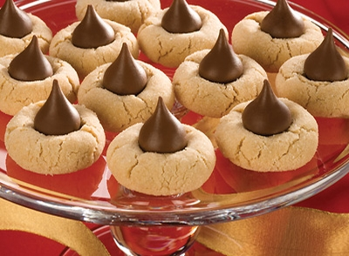

Ingredients
- 48 HERSHEY'S KISSES Brand Milk Chocolates
- 1/2 cup shortening
- 3/4 cup Creamy Peanut Butter
- 1/3 cup granulated sugar
- 1/3 cup packed light brown sugar
- 1 egg
- 2 tablespoons milk
- 1 teaspoon vanilla extract
- 1-1/2 cups all-purpose flour
- 1 teaspoon baking soda
- 1/2 teaspoon salt
- Additional granulated sugar

Directions
- 1 Heat oven to 375°F. Remove wrappers from chocolates.
- 2 Beat shortening and peanut butter in large bowl until well blended. Add 1/3 cup granulated sugar and brown sugar; beat until fluffy. Add egg, milk and vanilla; beat well. Stir together flour, baking soda and salt; gradually beat into peanut butter mixture.
- 3 Shape dough into 1-inch balls. Roll in granulated sugar; place on ungreased cookie sheet.
- 4 Bake 8 to 10 minutes or until lightly browned. Immediately press a chocolate into center of each
cookie; cookie will crack around edges. Remove from cookie sheet to wire rack. Cool completely.
About 4 dozen cookies.

